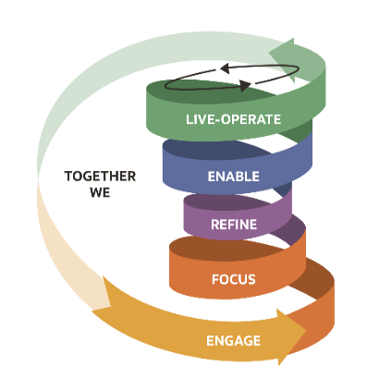
Design Specification
  - [Customer Name]
  - [Project Name]
XXX, 0000, Version [1.0]

PLEASE READ:
  - Please delete this page before saving your final document.
  - Please update Table of Contents after removing this page.
  - Text <<in brackets and in orange needs to be updated or removed>>.

Word template color theme for reference:
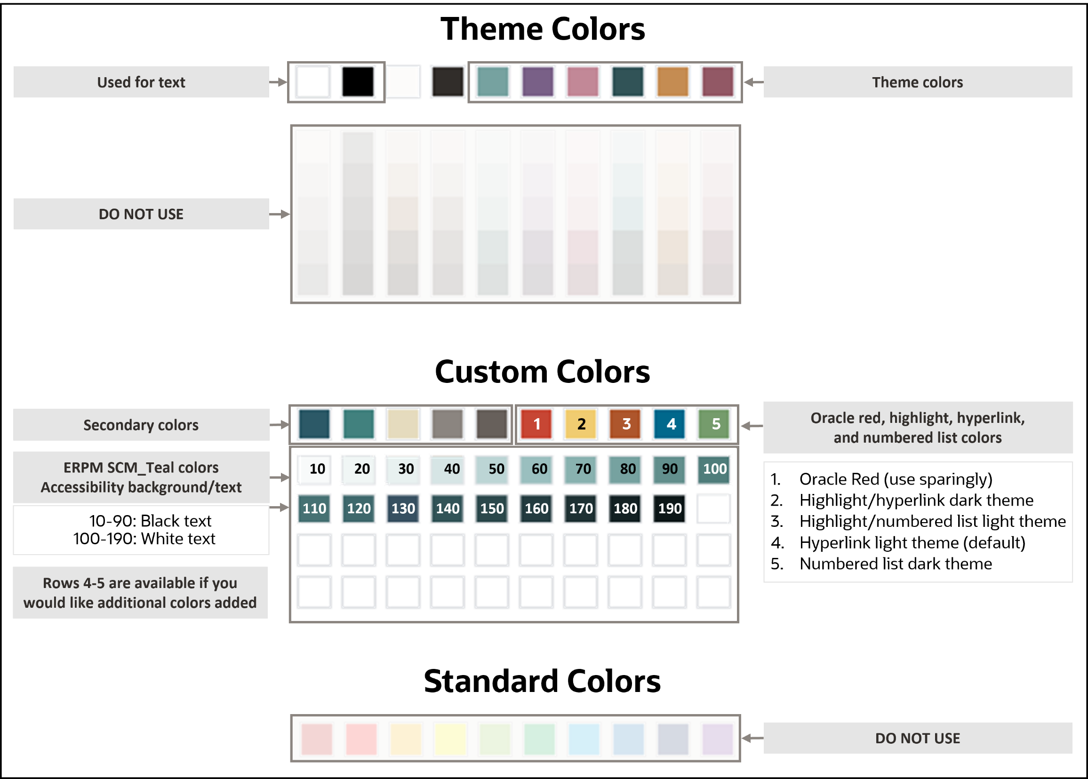

Using and applying styles
Styles incorporate information about spacing, tabs, and fonts and are critical to preserving the template’s design. Place cursor to see name of style applied.
The available styles for this template appear in a Styles menu. In Microsoft Word, there is a Quick Style Gallery on the Home tab that displays the most commonly used styles in this template. Clicking the dropdown arrow in the bottom right corner of the Quick Style Gallery shows a listing of all available styles. Another option is to click Control+Shift+S to display the Apply Styles dialog box.
Please delete this page before saving your final document.

Document Control

Change Record
Date | Author | Version | Change Reference

Reviewers
Name | Role

Approvers
Name | Role

Note to Holders:
If you receive an electronic copy of this document and print it out, please write your name on the equivalent of the cover page, for document control purposes.
If you receive a hard copy of this document, please write your name on the front cover, for document control purposes.

Table of contents
Using and applying styles 2
Document Control 3
Change Record 3
Reviewers 3
Approvers 3
Introduction 6
Business Objective 7
Audience 7
Salient Features 7
Assumptions 7
Glossary 8
References 8
Integration Design 9
Connections 9
Integration Pattern 10
OIC Integration Definition 11
Sequence Diagrams 11
Mappings and Transformations 13
Default Values 13
Lookups 13
Endpoint Configurations 14
Business Identifier for Tracking 14
Logging 15
Integration Analytics 15
Email Notifications 15
General Features 17
Error Handling 17
Technical Error Handling 17
Business Error Handling 17
Reprocessing / Resubmitting of the failed messages 17
Non Functional Requirements 18
Assumptions 18
Managing and Monitoring of the Integration 18
Volumetric Details 18
Security 18
Archiving and Purging 18
Performance Considerations 18
Open Questions 19

Introduction
<Consider Oracle secure coding guidelines for Oracle Software Security Assurance (OSSA) compliance>
<Customer Name> are implementing <details of implementation>. As part of this implementation an integration platform is being delivered using Oracle True Cloud Method.
<omit paragraph if not applicable> The Integration Catalogue lists the integrations that need to be built for the <project name> project/programme. The Integration Strategy document defines the principles and patterns to be used. Each integration listed in the catalogue is mapped in the strategy to one of these patterns.
Oracle Integration Cloud (OIC) has been selected as the platform to build and operate integrations between <add high level details>. Amongst its capabilities, OIC simplifies application integration, process automation and adaptive case management. It also includes recipes, pre-built integrations, 50+ SaaS and on premises adapters, a visual development environment, and operational and stream analytics—all available in a unified, seamless platform.
The purpose of this document is to:
- Set out the specification for the integration <add #, name and high level details>.
In common with Oracle True Cloud Method Solution Sets, this specification is based on best practice drawn from many successful implementations.
The key elements for this integration are shown in the following diagram.
<replace with a diagram appropriate to the integration>
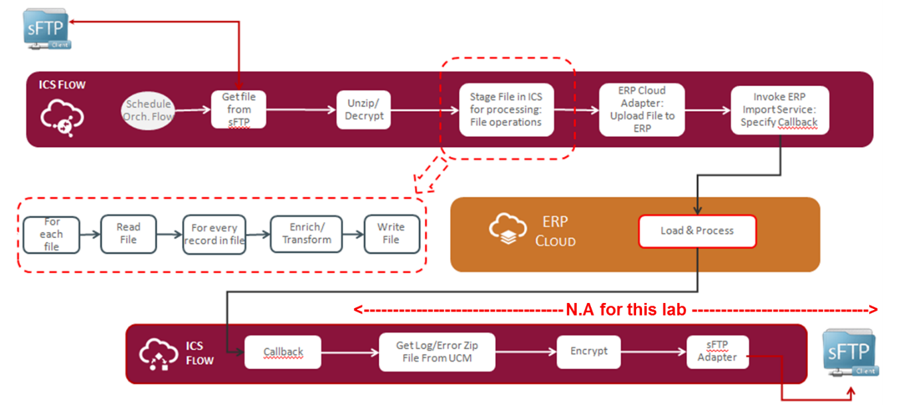

<Provide a very high level description of the elements in the diagram>

Business Objective
<Provide a very high level business requirement for this integration> Hence a custom Integration / integration needs to be designed for this requirement specific to <Customer>.

Audience
This document is primarily aimed at:
- <Customer> integration and solution architects
- <Customer> Design Authority
- Oracle designers and developers

Salient Features
The major features provided by this integration are:
<Provide one liner features in bulleted points to highlight the important features of this integration which in synch with the requirements and add if we if it is addressing any more value adds>
- Feature 1
- Feature 2
- …

Assumptions
<Provide all possible assumptions for which we do not have complete clarity>

- Assumption 1
- Assumption 2
- ….

Glossary
Abbreviation | Definition
API | Application Program Interface
FA | Fusion Applications – provided as SaaS
OIC | Oracle Integration Cloud
PaaS | Platform as a Service
REST | REpresentational State Transfer - an architectural API style for developing web services. Leverages HTTP rather than proprietary standards, frameworks and technologies
SaaS | Software as a Service
SOAP | Simple Object Access Protocol
TCM | True Cloud Method – implementation method solely available from Oracle Consulting
UCM | Universal Content Management. A document management system based on Oracle WebCenter Content embedded in Oracle Fusion Applications
WS | Web Service
WSDL | Web Services Definition Language

References
- <>

Integration Design

Connections
Connections are a basic building block as they are use the OIC adapters to connect to the applications that you want to integrate. The following connections are required for this integration:

Name | Role | Description | Identifier
HCM | Trigger and Invoke | Connection to HCM SaaS | HCM
UCM | Invoke | Connection to the HCM SaaS UCM repository | UCM
DB Agent | <Invoke> | Trigger | Trigger and Invoke | Connection to on-Prim Database | OnPrimDB
SaaS Agent | Invoke | This agent is installed and runs in Oracle Integration Cloud Service and supports communication with on-premises applications. | SaaSAgent

Each Connection has specific properties that are defined. When promoting or moving integrations between environments, the properties will need to be reconfigured to reflect the values applicable to the actual target applications. For the purposes of design, the values shown are for the development environments:

HCM Connection
Property | Value
Connection Administrator email address | <a group email id containing multiple individual email addresses is recommended>
HCM Services Catalog WSDL URL
Interface Catalog URL (optional)
Security Policy | Username Password Token
User name
Password
Client PGP Private Key
Client PGP Passphrase

<Refer to OIC documentation to compile a table for each connection needed with details specific to this integration>

Integration Pattern
OIC provides the following integration patterns:

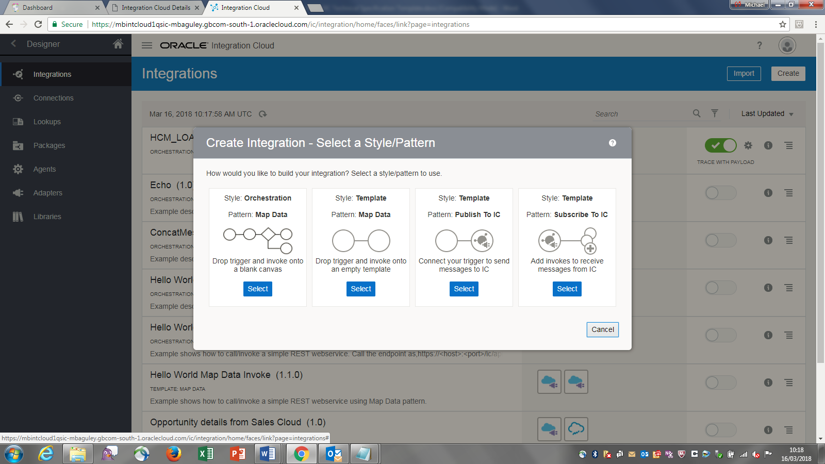

For this integration, the <name of style> pattern is required.

OIC Integration Definition
Property | Value
What triggers this integration? | Application event or Business event / Schedule
Describe this integration
What do you want to call your integration?
What does this integration do?
Identifier | <perhaps use integration catalogue reference>
Version | 01.00.0000
Which package does this integration belong to? | <E.g. define into a logical grouping of integrations to allow export and import by package>

Sequence Diagrams
The following diagrams depict the steps required in this integration. Each step is described underneath the diagram.

<The diagram will differ depending on the pattern that is required for the integration. The following is an example that would need to be implemented as an orchestration pattern>

<The diagram and descriptions of the steps will/can be adjusted or replaced during development to reflect the actual OIC build>

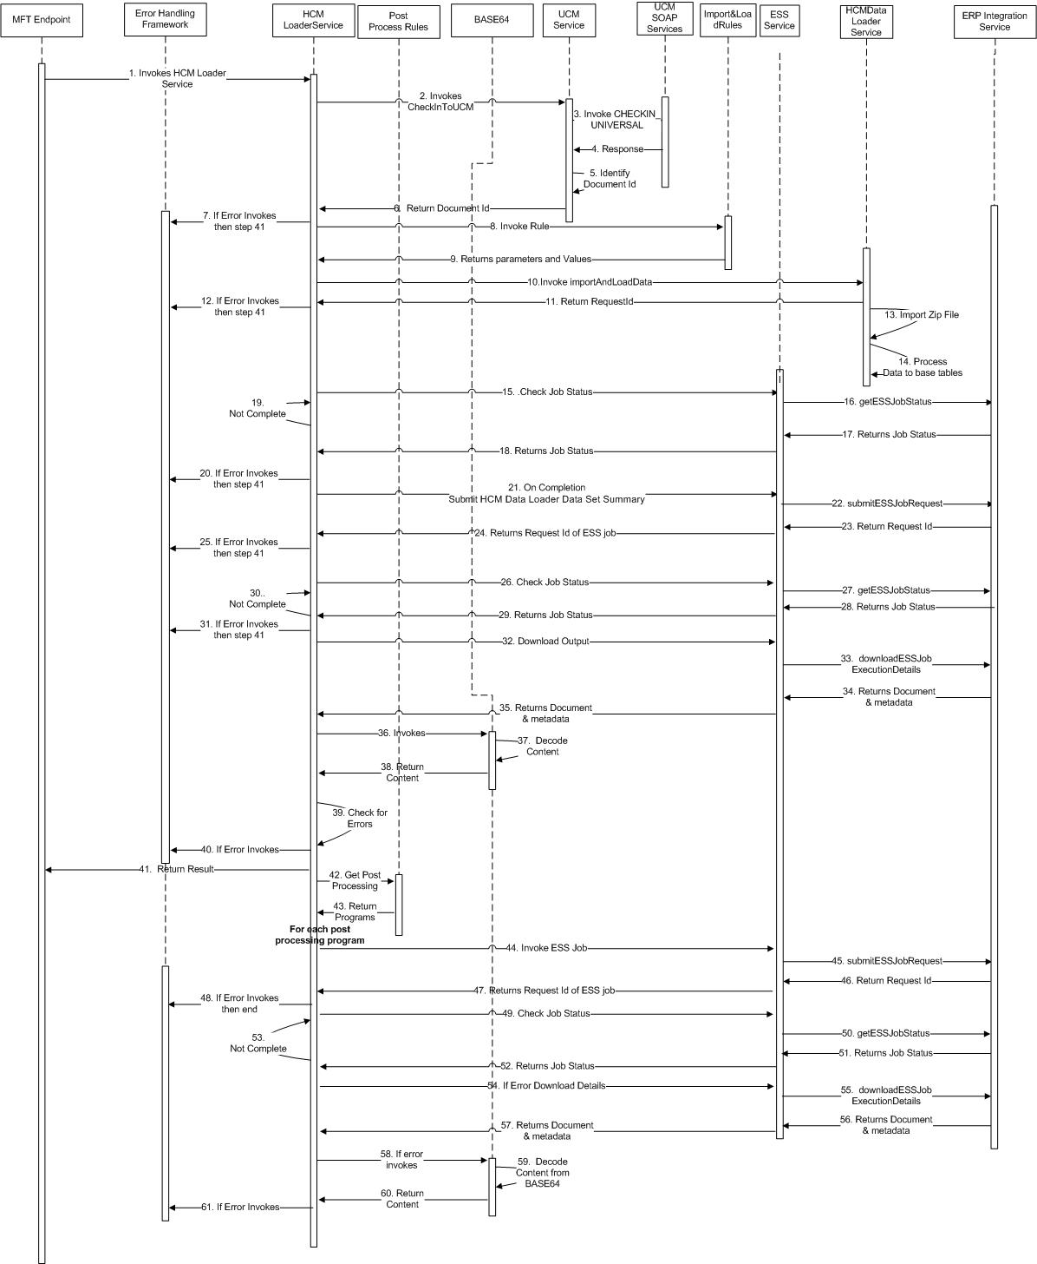

Step | Activity | Description
1
2
3
4

Mappings and Transformations
This section covers the Source to Target mappings, such as source file to FBDI template, as well as any notable mappings within the integration. If mapping is complete within the functional specification just refer the section. Only additional details to be included here.
Please note that all the internal mappings between activities within the integration do not need to be included and you should use the OIC application itself to view interim stage mappings.

Default Values
This section covers the default values needed for the integration and used in an.
Variable Name | Data Type | Description | Operation | Value

Lookups
Lookups are needed to assist with transformation between source and target representations of the data. The following are needed:

Lookup: <enter name>
Name | Description
SourceToTargetTitles | To transform titles from source to target format

Values
<Domain1 e.g MySourceApp> | <Domain 2 e.g. Oracle HCM>
Mr | Mr.
Mrs | Mrs.

Lookup: <enter name>
Name | Description

Values
<Domain1 e.g MySourceApp> | <Domain 2 e.g. Oracle HCM>

Endpoint Configurations
This section covers the configurations required for each of the connections (adapters) used for Invoke activities.

Invoke – HCM
Property | Value
What do you want to call this endpoint? | HCM
What does this endpoint do | Calls the LoadAndImport operation in the HCM DataLoader web service
What would you like to do with HCM Cloud? | Query, Create, Update or Delete information
Operation / Services | HCMDataLoader
Operation to perform | importAndLoadData
Lifecycle | Active
Description | Defaults

Business Identifier for Tracking
OIC integrations use key fields in the data being integrated for the purposes of tracking. The following will be used for this integration.
Primary | Tracking Field | Tracking Name | Tracking Variable | Help Text
Yes | Firstname | First Name | tracking_var_1 | Use the first name to track the data being integrated
 | Lastname | Last Name | tracking_var_2 | Use the last name to track the data being integrated

Logging
This section covers the logging activities added to the integration process.
Activity Log is after | When to Log | Logger Message
Invoke: UCM | Always | Loaded file: $filename
Stage File: ZIP | When trace is enabled | Completed zip activity

Integration Analytics
<Overview of how this integration is covered in Integration Analytics if installed.>

Email Notifications
This section covers the email notification activities added to the integration process.

Notification – EmailResult
Activity this notification follows: HCM

Parameters
Parameter Name | Description | Parameter Value
Result | Result from the HCM activity | $result

Property | Value
To
From
Subject
Body

General Features

Error Handling
Errors could occur in a number of situations. The following tables shows these and their handling:

Technical Error Handling
Error Scenario | Error Handling
Execution of an expression results in an unhandled fault in an expression language or query language | Error Monitoring
Explicit Fault in a process | Error process
Errors not specifically handled | Error Monitoring
No response from target process within configured timeout period | Error Monitoring

Business Error Handling
Error Scenario | Error Handling
File data insertion to table failed due primary key violation. | Error Monitoring
Required key field data not found in the file | Error process
…
…

Reprocessing / Resubmitting of the failed messages
<Provide all possible steps in each of failed message / file reprocessing cases>

Non Functional Requirements
OIC runs within the Oracle Cloud where the architecture is designed to provide customers with a unified suite of Cloud Services with best-in-class performance, scalability, availability, and security.

Assumptions
<Provide all possible non-functional assumptions for which we do not have complete clarity>

- <Data transformation not required for this flow>
- …

Managing and Monitoring of the Integration
- Standard product functionality used in each case – OIC Monitoring

Volumetric Details
Integration Name | Scheduled Frequency | Scheduled Parameters | Expected Volumetric Details (approximate)

Security
- Configure security for your connection by selecting the security policy and specifying login credentials.
- TBD

Archiving and Purging
- OIC integration instances are purged for every 3 days

Performance Considerations
- The performance of the seeded extracts, since they are standard, cannot be modified or optimized within the scope of this project.
- The file transfer from fusion UCM to the OIC SFTP server does not involve any transformation or processing of the extracted file. As such, the performance is likely to be affected by the network connection speed between the servers, and by the frequency at which is configured to transfer any files available for processing.

Open Questions
This section is used to summarise any open questions relating to this integration design and responses to these questions when known.

ID | Topic | Question | Status | Response
001
002
003
004
005
006
007
008

Connect with us
Call +1.800.ORACLE1 or visit oracle.com. Outside North America, find your local office at: oracle.com/contact.
blogs.oracle.com facebook.com/oracle twitter.com/oracle
Copyright © 0000, Oracle and/or its affiliates. This document is provided for information purposes only, and the contents hereof are subject to change without notice. This document is not warranted to be error-free, nor subject to any other warranties or conditions, whether expressed orally or implied in law, including implied warranties and conditions of merchantability or fitness for a particular purpose. We specifically disclaim any liability with respect to this document, and no contractual obligations are formed either directly or indirectly by this document. This document may not be reproduced or transmitted in any form or by any means, electronic or mechanical, for any purpose, without our prior written permission.
Oracle, Java, MySQL, and NetSuite are registered trademarks of Oracle and/or its affiliates. Other names may be trademarks of their respective owners.

